Kishan Sarpangala

M04307966

Assignment 3

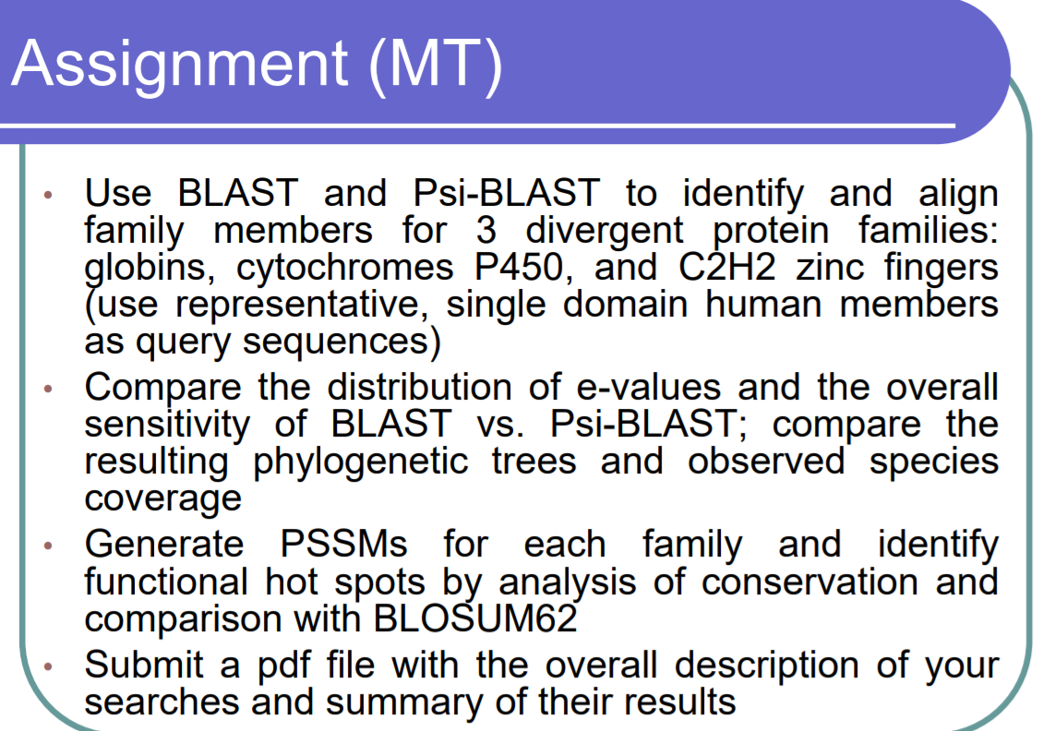

* Phylogenetic trees
* Species coverage?

C2H2 Zinc fingers